**Data Flow Coverage**

# writeFile() function Code:

**1- //Declaration of student name, id, gpa, grade, path;**

**public void write_file() throws IOException {**

**2- String filePath = path.substring(0, path.lastIndexOf('/') + 1) + "Results.csv";**

**3- try (FileWriter writer = new FileWriter(filePath)) {**

**4- StringBuilder contentBuilder = new StringBuilder();**

**5- contentBuilder.append("Subject Name:").append(course.getName()).append(",,,,,");**

**6- contentBuilder.append("Max Mark: 100\n\n");**

**7- contentBuilder.append("Student name,Student number,GPA,Grade\n");**

**8- for (Student student : students) {**

**9- contentBuilder.append(student.getName()).append(",");**

**10- contentBuilder.append(student.getId()).append(",");**

**11- contentBuilder.append(student.getGpa()).append(",");**

**12- contentBuilder.append(student.getGrade()).append("\n"); }**

**13- writer.write(contentBuilder.toString());**

**14- System.out.println("Successfully wrote to the file.");**

**}**

**}**

# Control Flow Graph:

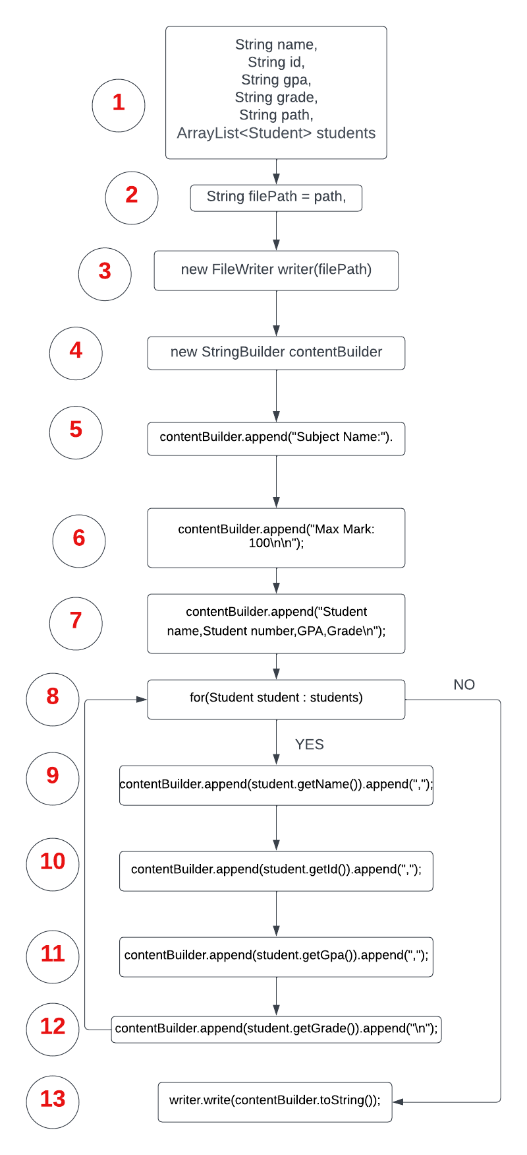

# Defined-Used Variables:

|  |  |  |
| --- | --- | --- |
| **Line** | **Define** | **Use** |
| **1** | name, id, gpa, grade, path, students |  |
| **2** | filePath | path |
| **3** | writer | filePath |
| **4** | contentBuilder |  |
| **5** |  | contentBuilder |
| **6** |  | contentBuilder |
| **7** |  | contentBuilder |
| **8** | student | students |
| **9** |  | contentBuilder, name, student |
| **10** |  | contentBuilder, id, student |
| **11** |  | contentBuilder, gpa, student |
| **12** |  | contentBuilder, grade, student |
| **13** |  | contentBuilder, writer |

# DU-Pairs and Paths for all variables:

**For the variable name:**

|  |  |
| --- | --- |
| **DU-Pair** | **Path** |
| **(1, 9)** | **<1, 2, 3, 4, 5, 6, 7, 8, 9>** |

**For the variable id:**

|  |  |
| --- | --- |
| **DU-Pair** | **Path** |
| **(1, 10)** | **<1, 2, 3, 4, 5, 6, 7, 8, 9, 10>** |

**For the variable gpa:**

|  |  |
| --- | --- |
| **DU-Pair** | **Path** |
| **(1, 11)** | **<1, 2, 3, 4, 5, 6, 7, 8, 9, 10, 11>** |

**For the variable grade:**

|  |  |
| --- | --- |
| **DU-Pair** | **Path** |
| **(1, 12)** | **<1, 2, 3, 4, 5, 6, 7, 8, 9, 10, 11, 12>** |

**For the variable path:**

|  |  |
| --- | --- |
| **DU-Pair** | **Path** |
| **(1, 2)** | **<1, 2>** |

**For the variable students:**

|  |  |
| --- | --- |
| **DU-Pair** | **Path** |
| **(1, <8, 9>)** | **<1, 2, 3, 4, 5, 6, 7, 8, 9>** |
| **(1, <8, 13>)** | **<1, 2, 3, 4, 5, 6, 7, 8, 13>** |

**For the variable filePath:**

|  |  |
| --- | --- |
| **DU-Pair** | **Path** |
| **(2, 3)** | **<2, 3>** |

**For the variable writer:**

|  |  |
| --- | --- |
| **DU-Pair** | **Path** |
| **(3, 13)** | **<3, 4, 5, 6, 7, 8, 13>** |
|  | **<3, 4, 5, 6, 7, 8, 9, 10, 11, 12, 13>** |

**For the variable contentBuilder:**

|  |  |
| --- | --- |
| **DU-Pair** | **Path** |
| **(4, 5)** | **<4, 5>** |
| **(4, 6)** | **<4, 5, 6>** |
| **(4, 7)** | **<4, 5, 6, 7>** |
| **(4, 9)** | **<4, 5, 6, 7, 8, 9>** |
| **(4, 10)** | **<4, 5, 6, 7, 8, 9, 10>** |
| **(4, 11)** | **<4, 5, 6, 7, 8, 9, 10, 11>** |
| **(4, 12)** | **<4, 5, 6, 7, 8, 9, 10, 11, 12>** |
| **(4, 13)** | **<4, 5, 6, 7, 8, 9, 10, 11, 12, 13>** |
|  | **<4, 5, 6, 7, 8, 13>** |

**For the variable student:**

|  |  |
| --- | --- |
| **DU-Pair** | **Path** |
| **(8, 9)** | **<8, 9>** |
| **(8, 10)** | **<8, 9, 10>** |
| **(8, 11)** | **<8, 9, 10, 11>** |
| **(8, 12)** | **<8, 9, 10, 11, 12>** |

# All-Du coverage:

**- Apply the test case on path <1, 2, 3, 4, 5, 6, 7, 8, 9, 10, 11, 12, 13> to achieve All-Du coverage, so that each definition for each variable reaches each use for each of them.**

**- Test case:**

**path = “.\\src\\test\\java\\InputFile TestCases\\fileName.txt”**

**students = {**

**name = “Alice Dodo”,**

**id = “15367901”,**

**activitiesMark = 5,**

**oralPracticalMark = 5,**

**midtermMark = 6,**

**finalMark = 60,**

**totalMark = 76,**

**grade = “A+”,**

**gpa = 4**

**}**

# readFile() function Code: